HCDTC Monthly Teleconference Meeting Minutes
February 14, 2020

This HCD TC Teleconference Meeting was started at 9:00 AM KST on February 14, 2020.

Attendees
- Kwangwoo Lee (HP)
- Anantha (Teron Labs)
- Brian Volkoff (Ricoh)
- Alan Sukert (Xerox)
- Nobushige Nomura (Canon)
- Cihan Colakoglu (Kyocera)
- Shin-ichi Inoue (ECSEC)
- Erin Huber (Xerox)
- Fumihiko Sano (Toshiba)
- Gerado Colunga (HP)
- Graydon Dodson (Lexmark)
- Futoshi Oseto (Ricoh)
- Toshiyuki Sato (Toshiba)
- Doug Grude (Ricoh)
- Matt Glockner (Lexmark)
- Ryuichiro Ohya (Fuji Xerox)
- Scott Chapman (Atsec)
- Kenji Takao (Fuji Xerox)

Notes

- Recap the HCD TC meeting (February)
  - https://collaborate.ccusersforum.org/wg/HCD_TC/document/382
- Collaboration tool Updates
  - Set up the environment at the Github (Target: End of 2019)
    - Done. Alan got the environment setup.
  - Transfer the HCD PP to Github (Target: early 2020)
    - 25% done. Alan started to transfer the HCD PP into the cPP template that Brian Wood set up.
    - Asciidoc is not exactly easy to work. Jerry will contribute this activity.
    - Editors are not ready to report the progress. Editors are not waiting the HCD iTC approval. Rather, they are going to make a progress soon. Editor will share the HCD cPP version 1.0 before HCD TC F2F meeting in Burlington.

- Update the HCD iTC progress
  - HCD iTC is not endorsed yet by CCMC. Kwangwoo reminded the CCMC Voting to ITSCC and CCMC Chair. Kwangwoo finally got the answer from CCMC chair regarding CCMC Voting as below
    - CCMC Chair sent out the vote for the HCD iTC endorsement and SD rationale acceptance to the MC members. The voting time limit is set to Feb 5th, 2020.
    - AI- Kwangwoo to check the voting result of CCMC

- HCD cPP development milestone
  - We decided to follow the existing milestone that was proposed by last month.
    - 1~6 month: 1st Working Draft (Starting from 2020)
    - 7~12 month: 2nd Working Draft
    - 13~18 month: SMEs Review (call for comments and comment resolution) v0.8.x
    - 19~23 month: Public Review (call for comments & comment resolution) v0.9.x
    - 24 months: HCD cPP v1.0 (Final Version)
      - Target date: 2022 1Q
  - Review the iTC/cPP Process paper
    - Focus on the figure 3: Process Flow Diagram for cPP Development
- Sub WG Establishment
  - TLS 1.3: Ira McDonald (Draft: June 2020)
    - Feb 2020 - set up the TLS 1.3 session (30 minutes required) – Defer this discussion to next meeting.
    - NDcPP: TLS 1.3 ciphersuite of ND cPP
  - Hardware-anchored integrity verification: Jerry Colunga (Draft: June 2020)
    - Not so much progress in January. Jerry will make a progress and share it in our next F2F meeting.
  - SED & HDD Encryption: Alan Sukert (Draft: June 2020)
    - Need to align with FDE cPP
    - Not so much progress in January. Alan will contact to FDE iTC to figure out the status. It will be updated until next meeting.
  - Ira is willing to support the resource for the all items.

- Roundtables
  - If you cannot access the Causeway, please contact to Kwangwoo (kwangwoo.lee@hp.com)
  - https://collaborate.ccusersforum.org/wg/HCD_TC/dashboard
  - HCD iTC SMEs status
  - Industry SMEs (36), Lab SMEs (20), Certification Body SMEs (4), Other SMEs (6)

Action Items for February HCD TC meeting
- AI – Kwangwoo to update the CCMC voting status (HCD iTC endorsement & SD rationale acceptance)
  - There was no update from CCMC at this moment. Kwangwoo will check the status again.
- AI – Kwangwoo to follow up the HCD iTC activities based on iTC/cPP process paper
  - It will be reviewed after HCD iTC is approved.
- AI – Kwangwoo to check the Causeway license whether it requires the backup or migration
  - Kwangwoo did some back up to prepare the unpredictable accident in Causeway.
- AI – Kwangwoo to send out the CCUF HCD TC F2F meeting plan to CCUF MG
  - Done. The next F2F meeting will be held on Wednesday 18th March, 2020 at 09:00 -11:30AM. It can be extended if we need more discussion.
- AI – Editors (Alan, Jerry, Brian) to transfer the HCD PP to Github (Progress: 25%)
  - Team is not ready to report the progress. Editors are not waiting the HCD iTC approval. Rather, they are going to make a progress soon. Editor will share the HCD cPP version 1.0 before HCD TC F2F meeting in Burlington.
- AI – Ira to prepare the summary presentation of TLS 1.3 Sub WG (Max. 30 minutes)
  - Defer discussion to next meeting.
- AI – Ira to share the HCD Security Guideline if it is ready to share
  - Defer discussion to next meeting.
- AI – Jerry to make a progress regarding the Hardware-anchored integrity verification Sub WG.
  - Jerry is not ready to report progress. This topic will be added in the agenda of next F2F meeting next month.
- AI – Alan to make a progress regarding the SED & HDD Encryption Sub WG so that it can be align with FDE cPP.
  - Alan is not ready to report progress. This topic will be added in the agenda of next F2F meeting next month. Anybody of HCD TC is welcome to join this activity.
- PWG IDS F2F Meeting Minutes
  - The minutes from the February 6, 2020 PWG IDS Face-to-Face Meeting have been posted on the PWG IDS FTP site and are available at ftp://ftp.pwg.org/pub/pwg/ids/minutes/ids-f2f-minutes-20200206.pdf
  - The slides presented at the meeting can be found at https://ftp.pwg.org/pub/pwg/ids/Presentation/2020-02-06-IDS-F2F.pdf.

Action Items for March HCD TC F2F meeting
1. AI – Kwangwoo to update the CCMC voting status (HCD iTC endorsement & SD rationale acceptance)
2. AI – Kwangwoo to follow up the HCD iTC activities based on iTC/cPP process paper
3. AI – Kwangwoo to check the Causeway license whether it requires the backup or migration
5. AI – Editors (Alan, Jerry, Brian) to transfer the HCD PP to Github
6. AI – Ira to prepare the summary presentation of TLS 1.3 Sub WG (Max. 30 minutes)
7. AI – Ira to share the HCD Security Guideline if it is ready to share
8. AI – Jerry to make a progress regarding the Hardware-anchored integrity verification Sub WG.
9. AI – Alan to make a progress regarding the SED & HDD Encryption Sub WG so that it can be align with FDE cPP.

Next meetings
- CCUF F2F Workshop
  - Oracle Burlington, Massachusetts, US/ March 17-19, 2020)
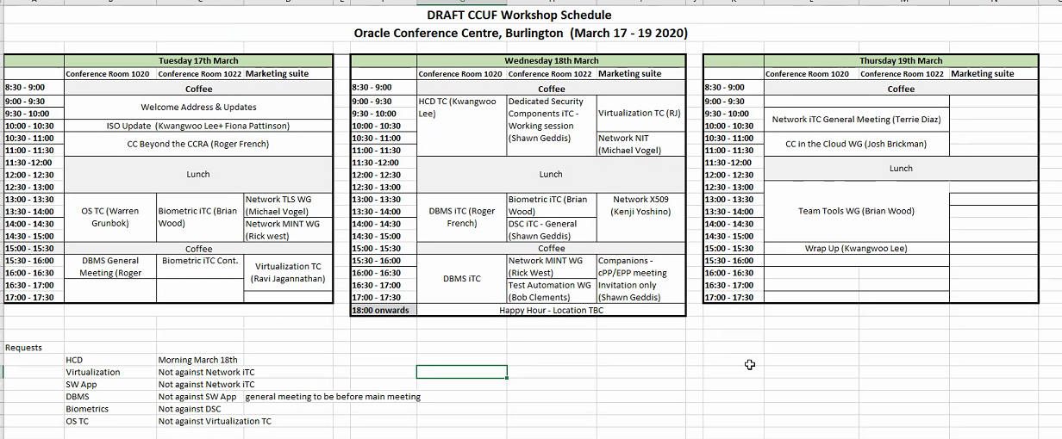

This HCD TC Teleconference Meeting was completed at 9:30 AM KST on February 14, 2020 (Seoul/Tokyo).

